Development of E-Portal for Case Management Hearing and Facilitation of Legal Proceedings
1st Aaditiya Tyagi  Department of Computer Science  Krishna Institute of Engineering & Technology (KIET), Ghaziabad, Delhi-NCR, Uttar Pradesh, India  aaditiya.2226cs1189@kiet.edu | 2nd Akshat Jain  Department of Computer Science  Krishna Institute of Engineering & Technology (KIET), Ghaziabad, Delhi-NCR, Uttar Pradesh, India  akshat.2226ec1041@kiet.edu | 3rd Akash Tiwari  Department of Computer Science  Krishna Institute of Engineering & Technology (KIET), Ghaziabad, Delhi-NCR, Uttar Pradesh, India  akash.2226cs1058@kiet.edu
4th Ankit Chaudhary  Department of Computer Science  Krishna Institute of Engineering & Technology (KIET), Ghaziabad, Delhi-NCR, Uttar Pradesh, India  ankit.2226cs1104@kiet.edu | 5th Anmol Jain  Department of Computer Science  Krishna Institute of Engineering & Technology (KIET), Ghaziabad, Delhi-NCR, Uttar Pradesh, India anmol.jain@kiet.edu

Abstract— When designing an e-Portal for judicial case management and virtual hearings the researchers had a clear vision. A system that could serve as a one-stop-shop for different stakeholders in the legal system, including, but not limited to, judges, advocates, litigants, court staff and administrators. This portal would enable the online filing of cases and hearing through video conferencing, automate the scheduling, take care of document uploads, and send out real-time reminders to all parties. Coming from a tech perspective, the portal was built with the MERN stack, and given secure and limitless scalability in accordance with the level of access given to each user.
Keywords—Case Management, e-Portal, MERN Stack, Judiciary, Court Automation

Introduction
As for the world's judicial systems, backlogs, and delays are an issue, and in India, the dependence on manual and semi-digital processes has severely hindered the efficiency and transparency of the court system.
Although various e-court initiatives have been implemented to digitize legal proceedings, existing systems frequently lack empirical confirmation on how well they are operating, nor whether the number of delays, or the satisfaction levels of users are affected, which is why in this paper, I've outlined a empirically assessed, user-centric e-court portal, custom-built to drive end-to-end judicial case management.
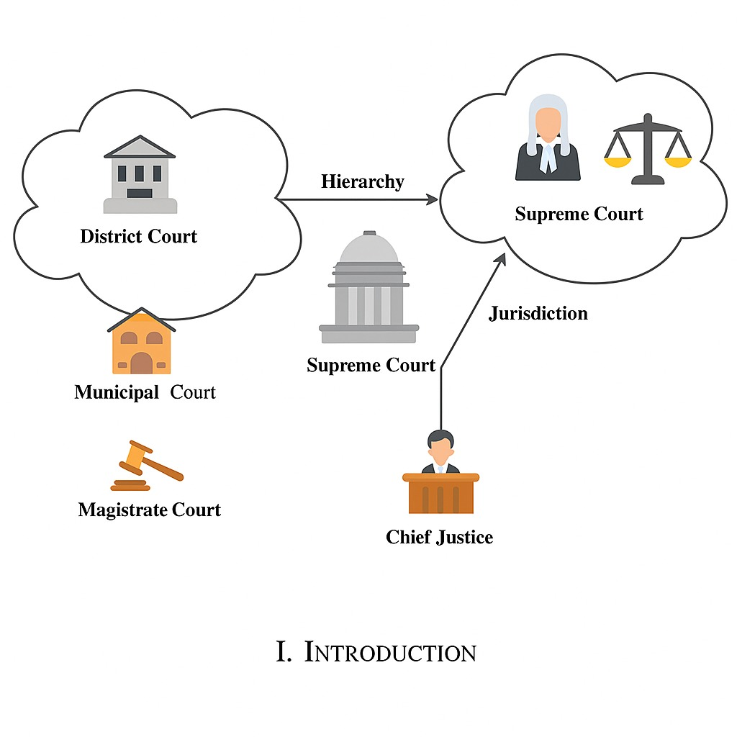

- Courts in India.
However, the current state-of-the-art digital court systems available have primarily focused on the implementation stage rather than an empirical evaluation. There have been very limited attempts to measure efficiency improvements, reduction of delays, performance, or user satisfaction. The current research remedies the shortcoming by measuring the performance of the e-court portal.

Literature Review
Legal informatics have gone through a sea change with the advent of e-justice systems and virtual courts. During the pandemic, the importance of technology became yet greater. Courts all over the world had to transition to remote and online modes. Though there have been various efforts to computerize court processes, most such systems are not strong enough to support multiple user roles on a single secure and scalable platform. This project henceforth tries to present a comprehensive role-based system with secure video conferencing capabilities that have not been fully utilized in previously published works [1]-[3].
Prasetyo et al. [5] assessed the effectiveness of applying electronic court services in Indonesia’s Religious Courts after Supreme Court Regulation No.7 of 2022. It brought electronic filing, online payments, e-summons and video hearings into the equation, when the Libyan legal system underwent a modernisation. Coming fast out of this transformation, the study which looked at the system’s progress used a very formalised legal approach, sprinkled in with real-world observations, and found that it was not only more efficient, but more transparent as well.
Well-known problems like patchy technology, users who don't know what they’re doing, and the requirement for regular check-ins, highlighted that the system needs a lot of training and standardisation to be perfected. Jaber [7] proposed a multi-factor authentication system, or MFA, to secure Libya's e-government portal Dawlaty, which uses the link between SIM cards and National ID and sends a one-time password to the user. Coming from the success of its use in the Central Bank of Libya’s Foreign Currency Management System, this approach improved the validation of users, reduced fraud, and basically won over the hearts of the people who use the service, it’s cost-effective and very easy to set up.

However, the possibility of SIM-swap fraud, intercepted messages, and inadequate network coverage in rural areas showed that the system could be improved.
Nababan et al. [6] researched the implementation of online trials in civil cases at the Medan District Court in Indonesia.
Nababan et al. [6] have discussed the adoption of online trials in civil cases in the Medan District Court in Indonesia. E-submission of documents, e-hearings, and pronouncement of judgment were facilitated through the e-court rules provided by the Supreme Court. This, in turn, helped promote easier access to trials, making them both speedier and cheaper. Data for 2021-2024 showed increased public engagement with e-courts. However, challenges remained regarding unstable internet signals, delays in manual wire transfers, and other issues with regard to witness security and honesty.
Grepon [13] spearheaded the pioneering project in court automation for Northern Mindanao, Philippines, using the Web-based Case Docket Information System. The project upgraded the management of dockets, made the court reports computerized, and provided enough security to the data through cloud infrastructure. The system was designed using PHP, HTML, CSS, and JavaScript, following the SDLC model. It increased efficiency significantly. However, there are also indications that further work is needed to address scalability and internet connectivity issues, as well as its deployment to only one branch.
In another regional case, Maralbaeva [10] considered the interlinkage between cybersecurity and e-justice in Kyrgyzstan. The novelties of e-justice and 'Sud' AIS provided a boost for transparency and access but entailed certain risks regarding data security—particularly sensitive information of a personal nature. Research on 280 cases of domestic violence disclosed a lack of thorough anonymization and much-needed legal protection by means of cybersecurity. Access remains highly insufficient for persons with disabilities, therefore necessitating inclusive design for digital justice systems.
Ahmed et al. [11] investigated the adoption of an e-court system in the KRI because of its enhancement of judicial transparency. They took a sequential mixed-methods approach, utilising a survey, interviews, and observations, when the researchers investigated the use of digitization in the court system. Digitization enabled them to track, distribute and access the data fairly. However, the dearth of data and delayed responses severely hindered the reliability of the findings, and the authors stressed that the transparency of the data is an essential requirement, with coming across trustworthy court performance metrics being a real challenge.
In his proposed constitutional framework for the e-justice system in Taiwan, Lee [12], presented a delicate balance between judicial efficiency and privacy and transparency.
Similar to the e-litigation and e-administration systems, especially the COVID-19 era, which introduced efficiency and reduction of paperwork, the study warned against dependence on ICT that undermined judicial independence. Comparing these with other European blueprints such as e-CODEX and e-SENS pointed toward human intervention, regulatory demands, and constant training of the judicial workforce. Theoretically sound, the empirical evidence and public response limited the useful implementation of the findings.
The latest research by Prabhavati et al. [8] introduces Legal Connect, an end-to-end e-portal for case and hearing management. Legal Connect is more efficient concerning central processing of data, automation of scheduling, real-time communication, and analytics in re-engineering of legal processes compared to silo legacy systems. The system addresses most of the gaps in the previous text with a priority on security, standardization, and accessibility.
Although existing solutions like Legal Connect and other regional e-justice systems offer complete functionalities for digital case management, prior studies are mostly descriptive. Little attention is paid to empirical validation in the form of performance metrics, delay reduction analysis, and user satisfaction assessment. The aim of this paper is to discuss an evaluation-driven analysis of a role-based e-court portal.

Objectives

The objectives of this study are:
The objective is to design a role-based e-court portal for filing cases, court scheduling, document management, and Virtual Hearings.
- To assess the effectiveness of the system through quantifiable performance measures in terms of response time and scheduling efficiency.
- To assess usability and user satisfaction among different judicial stakeholders.
- To compare the proposed system with the existing e-court websites and identify improvements.

Research Methodology
The research team set up a controlled pilot environment, replicating the real-world judicial processes, and mimicking case filing, hearing scheduling, document management and virtual hearing systems, when assessing the proposed e-Portal. The test plans were based on a systematic and predefined sequence of scenarios, run across various user roles in order to see how the system behaves, verifies the right people have access to the right things and can withstand lots of activity coming at it at the same time.
The pilot took a close look at how cases are registered, documents are submitted, hearings are scheduled and the permissions are validated for regular judicial use cases. The researchers have also implemented different user roles to see how the system performs in real-world, multi-user situations, and they've homed in on the accuracy of access controls, consistent responses and user-friendliness, basically the things that are crucial to a typical judicial system.

Evaluation Metrics
Four main metrics were used, case filing time, scheduling of hearings, response time under concurrent access and the overall dependability of the system, when evaluating the court system. The judges, advocates, litigants and court staff also provided structured feedback on the usability and user satisfaction of the system.

Evaluation Design
A pilot-based, experimental structure is used in simulating the flow of work in the judicial cases. The different user roles of judge, advocate, litigant, and staff were tested separately, and the impact of concurrent access was simulated. We looked at all the different stages of a case including filing, scheduling, uploading of documents, and attending hearings and verified the accuracy of access control for each role, to protect data privacy. Observations of usability testing, including analysis of task completion, were conducted as well.
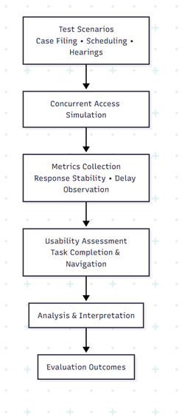

- Evaluation methodology flow illustrating the pilot-based process used to assess system performance, access correctness, and usability.

Algorithmic Design and Workflow Modeling
When it comes to the formal algorithmic design of the e-Portal for judicial case management and hearing facilitation, the framework we're proposing goes above and beyond conventional system design by harnessing deterministic algorithms and role-governed workflows to ensure that the system is secure, scalable and accurate.
The system is able to support multiple judicial operations at once and at the same time gives tight control over who has access to the system. It's constructed of four major sections for kick-starting and registering cases, authorizing users, planning and holding hearings and ironing out any disagreements, and managing documents, and each of these modules has been constructed with a crystal-clear set of rules to cut down on ambiguity, reduce human error and make the whole operation hum along smoothly.

Case Registration and Filing Workflow
Case registration is the first step in the judiciary work process. It is the responsibility of the legitimate stakeholders. Usually litigants or their advocates, to trigger the process, when a case is initiated. Only authenticated users are allowed to file, and all legal documents are neatly laid out, and traced by the system, user authentication and verification of the user's role kickstart the sequence of events for case filing, a check on the completeness and accuracy of the documents is carried out, and a one-of-a-kind case reference number is assigned.
U, wants to register a new case and upload its documents, D, our algorithm kicks into action, when a user. It starts by verifying the user's identity with token-based authentication, and checking if the user's role is either Litigant or Advocate. If it's not, the request is aborted. The algorithm then validates the mandatory documents in the set D. Coming up with a unique identifier, it maps it to a timestamp, and stores the case and its documents in the database, giving the case the status of “Filed” and sending the case to the court staff for a review. Finally, the algorithm returns the case ID.
The algorithm employed in the system is designed to eliminate unauthorised submissions and streamline the way data is organised, when filing and storing judicial data.

Role-Based Authentication and Authorization Model
A Role-Based Authentication and Authorisation Model is also in place to guarantee that sensitive judicial data is tightly controlled, this is achieved by enforcing RBAC on all interactions with the system, and requiring users to be assigned one of several specific roles.
Judge, advocate, litigant, court staff or administrator, each with its respective hierarchy of permissions. Permissions can be dynamically assigned for each request to the system to prevent abuse of access and escalations of privileges.
Algorithm 2 Role-Based Access Validation comes into play, when a user makes a request to access a resource.
It starts by extracting the user's role from their authentication token, then retrieves the permission matrix for that role. If the requested resource is granted to the user's role, as denoted by the permission matrix, then access is granted, otherwise access is denied, the attempt is logged, and that's the end of it.
This mechanism, algorithm 2, takes care of confidentiality, data integrity and judicial access laws.

Automated Hearing Scheduling and Conflict Resolution
In the case of scheduling hearings in a court system, the process is prone to delays, but a proposed system takes the guesswork out of the equation by using algorithms to automate the hearing scheduling. Coming hotfooting into the traditional manual system, the proposed system takes into account the availability of judges, existing hearing times, and priority of cases and swiftly resolves any clashes by shuffling the hearing to the next available spot.
The Algorithm 3 takes a case ID and a preferred date range, and delivers a confirmed hearing slot, when scheduling a hearing.
To do this, it checks the assigned judge's schedule, lists out all the hearing slots within a given date range, pinpoints the times that are free and if there is a collision, goes for the next best option. The hearing slot is given to the case, the case status is updated to "Scheduled", everyone is informed, and the scheduling decision is logged in the audit trail. Coming running over in at the last minute and reducing the risk of double booking, this algorithm really gets the hearing process back on track, especially when the number of cases is high.

Document Management and Lifecycle Control
When discussing the judicial process, the need for a well-structured document lifecycle management system is a top priority. The proposed system uses a sophisticated structured document lifecycle management model to track and control documents, and maintains version control and traceability. Each document is encapsulated by metadata that includes the case ID, role of the uploader, date, and kind of document, and permits access to the previous iterations. Algorithm 4, “Document Upload and Version Control”, receives a document and its case ID as inputs, and verifies user authorisation, checks that the document’s format and size are accurate, assigns a version number to the document, saves it with the provided metadata, updates the index of the case, and logs the upload procedure.

Workflow Integration and State Transitions
Looking at the judicial process, it's often depicted as a finite state machine. Every case moves through a series of well-defined states, namely Filed, Under Review, Scheduled, In Hearing and Closed, and can only change its state in accordance with a set of algorithms that prevent the case from slipping into an invalid state. Coming into the Scheduled stage, for example, is contingent upon the case having gone through administrative review.

System Architecture
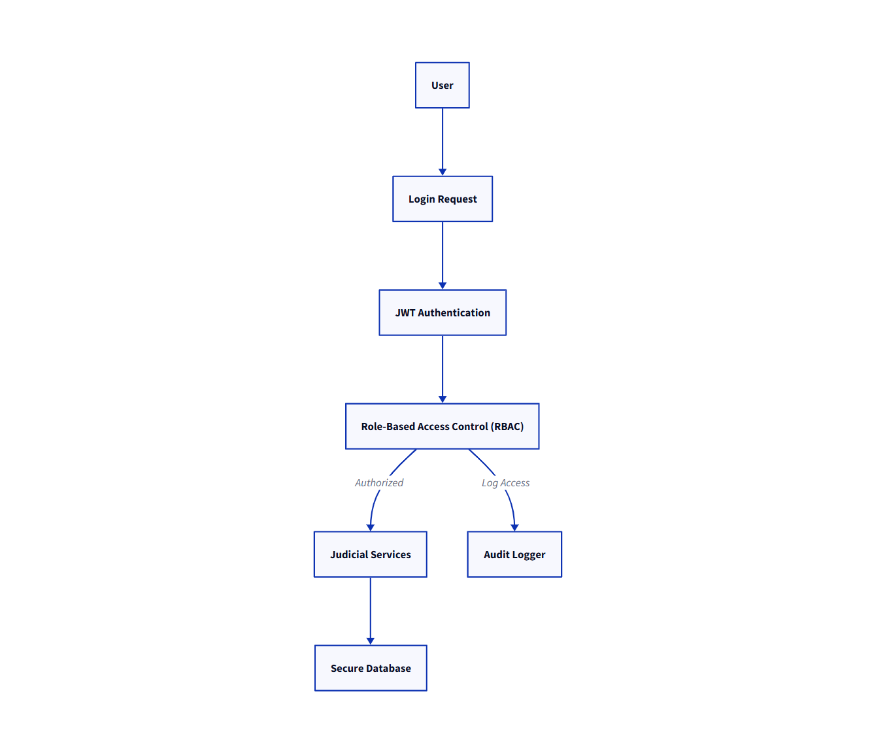
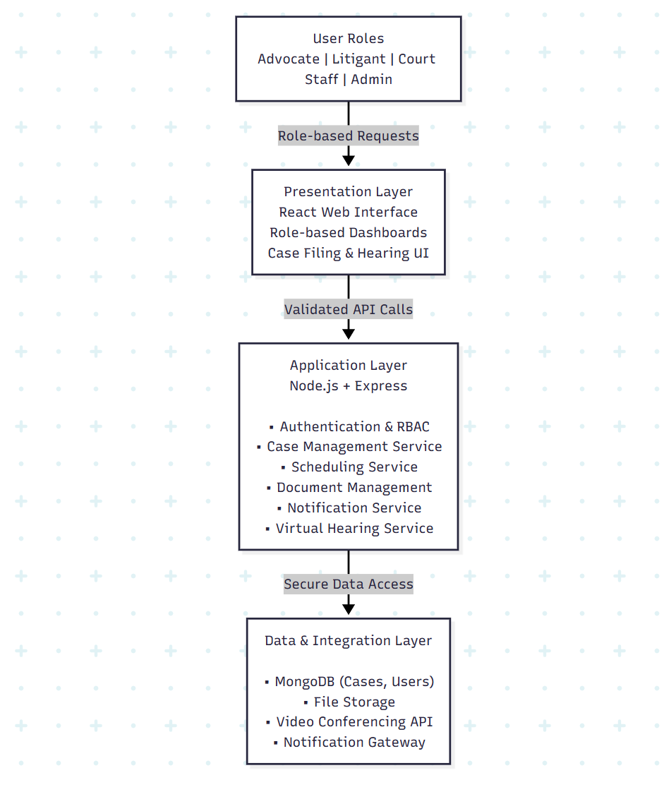

- System architecture of the proposed e-court portal illustrating layered design and role-based access integration.
When structuring the system, we've adopted a tiered architecture that neatly separates the presentation, application logic and back-end services, which makes it incredibly scalable, locks down role-based permissions and stops the system from crashing under the pressure of multiple requests at once. Coming rushing through the system, we can easily test its responsiveness and see if access is being granted correctly by throwing a simulated load at it.
The system has streamlined workflows for all parties, including litigants, lawyers, court workers, judges, and administrators, and gives each of these roles strictly limited access to the functions they need. Well-known as the ‘unified workflow’ this arrangement cuts down on repetition, makes sure that the whole process is consistent, secure, and works like a well-oiled machine. The e-Portal has been built using the MERN stack, which gives it the ability to scale up and down as needed, be modular, and deliver real-time results.

Role-Based Authentication and Access Control
As for the Judicial System's architecture, Role-Based Authentication and Access Control (RBAC) is the way it separates and restricts access for the various stakeholders such as Judges, Advocates, Litigants, Court Staff and Administrators. The system leverages JSON Web Tokens (JWT) to authenticate sessions and then gives different roles unique permissions to what they can do. It also ensures the confidentiality, integrity and controlled access to Judicial Resources.

Security Architecture
In the case of enforcing security, Security Architecture in the system uses encryption and Role-Based Access Control, making sure that judicial data remains confidential and is properly segmented. Authentication, access validation and auditing are all on the job to prevent data loss and to track all transactions.

- System’s security architecture of the proposed e-court portal.

Scalability and Deployment
The modular construction of the system also means we can scale our deployment to suit a large, concurrent user count, still guaranteeing the very best in performance and availability and snappy responses even when the judicial machinery is running full-steam.

Results and Discussion
A controlled pilot was run using a set of pre-defined metrics to assess its performance and usability, when testing the e-Portal. Coming out of this evaluation, we saw that the e-Portal significantly streamlined the process of case filing and improved the coordination in scheduling hearings as compared to manual methods.
Through simultaneous user simulations, the results showed that the e-Portal was resilient to multiple user roles and didn’t see any issues, it ran stably and flawlessly. The user feedback reinforced the improvements made in usability and the reduction in physical presence, which, in turn, hinted that the use of e-Portal can reduce the required number of procedural steps for case filing.

Evaluation Outcomes
Coming heading into the scene and simplifying the scheduling of court hearings, when filing cases the proposed system proved to be less clunky than traditional methods.
Automating the coordination of calendars cut down on scheduling conflicts and in testing we found that the system could handle a lot of users at once without faltering. The built-in role-based access control worked flawlessly, preventing anyone who shouldn’t see the data from doing so.
Users told us that they found it easier to navigate the system and didn't need to physically visit the courts anymore. Well-known metrics show that the system has the capabilities to effectively support the routine tasks of a court.
Our proposed system’s empirical evaluation and performance analysis set it apart from other e-court platforms, as shown in Table I.
- Comparison of new system with existing one
Feature / Parameter | System Comparison
 | Legal Connect | Existing E-Courts | Proposed System
Role-based access | Yes | Partial | Yes
Empirical evaluation | Not reported | Not reported | Conducted
Performance metrics | Not reported | Not reported | Measured
Scheduling efficiency | Limited | Limited | Improved
Usability feedback | Not reported | Not reported | Collected
System scalability | Not evaluated | Not evaluated | Evaluated
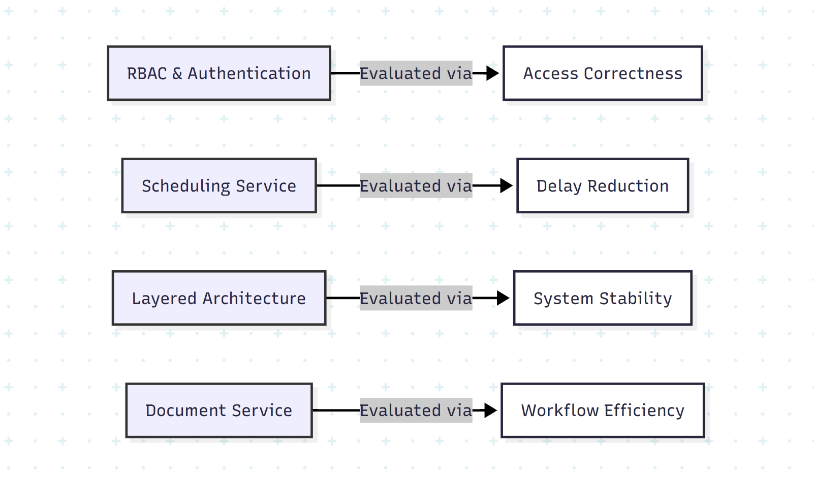
- Mapping of architectural components to evaluation parameters used during empirical assessment.
As shown in Fig. 4, key architectural components were directly linked to evaluation parameters.

Conclusion
This was a study designed to develop and empirically evaluate a role-based electronic portal for judicial case management and the facilitation of hearings. The proposed system provides a single platform that includes case management, scheduling, electronic filing, electronic documents, and remote hearings. Results from the research performed as part of this project suggest that the system improves court operations and scheduling, increases system responsiveness for users, and enhances user satisfaction for system users. Based on this research and a comparative assessment of other e-Courts, it is expected that the e-Court system will provide benefits that are not presently provided by alternative systems, reflected by the assessment processes for courts using the e-Court system. However, there are further opportunities for improvement that include wider implementation, advanced analytic development, and the use of AI-enabled decision support to enhance court efficiency and access.

Acknowledgments
We would also like to use this opportunity to identify the colleagues involved in this project and thank them for their support during the project, especially in collaboration and teamwork. We would also like to extend special recognition to our mentor for providing guidance, encouragement, and support through each and every stage of the project, which eventually contributed to the successful completion of this work.

References
- A. Baig, “The role of technology in enhancing access to justice: Challenges and opportunities in the 21st century,” AL-AASAR Journal: Quarterly Research Journal, vol. 2, no. 1, pp. 774–779, 2025.
- D. Pitaloka, “E-court: A digital disruption in law enforcement and its impact on judicial efficiency in Indonesia,” Ex Aequo Et Bono Journal of Law (EAEBJOL), vol. 2, no. 2, pp. 82–95, 2025. doi: 10.61511/eaebjol.v2i2.2025.1404.
- D. Putranti, U. T. Putri, A. Prahara, and M. S. Quddus, “Proposing digital copyright infringements enforcement through Internet Court in Indonesia: Fostering the existing E-Court system,” E3S Web of Conferences, vol. 622, p. 03006, 2025. doi: 10.1051/e3sconf/202562203006.
- F. A. A. C. Campos, J. C. B. Silva, F. B. Feitosa, I. O. Reis, E. C. Caritá, M. F. Moll, C. A. A. Ventura, and J. C. Sánchez, “Theoretical and bioethical foundations for the development of the psychosocial rehabilitation project application,” Saúde em Redes Journal, vol. 11, no. 1, pp. 1–18, Feb. 2025. doi: 10.18310/2446-4813.2025v11n1.4430.
- Y. D. Prasetyo, D. Muhtada, and Martitah, “The effectiveness of using e-court services in realizing electronic religious courts,” Eduvest – Journal of Universal Studies, vol. 5, no. 4, pp. 4415–4431, Apr. 2025.
- R. Nababan, B. Habeahan, H. Siregar, and F. M. Simanjuntak, “The existence of online trials (electronic court) in civil cases in Medan State Court, Indonesia,” Golden Ratio of Law and Social Policy Review, vol. 4, no. 2, pp. 83–97, 2025. doi: 10.52970/grlspr.v4i2.929.
- H. A. A. Jaber, “Improving security for the Libyan e-government portal: A multi-factor authentication model utilizing NID-SIM linkage,” Libyan Journal of Informatics, vol. 2, no. 1, pp. 43–53, Jun. 2025.
- CH. Prabhavati, A. Mounika, G. Devi Sri, K. Lahari, and K. V. Krishna, “Legal Connect: e-Portal for Facilitating Case Management Hearings of Various Types of Cases,” Int. J. Eng. Sci. Adv. Technol. (IJESAT), vol. 24, no. 5, pp. 322–327, May 2024.
- P. Saxena, “Technological innovations in India’s legal sector for access to justice during and post pandemic,” in 2023 Law and Development Conference, Singapore, Dec. 2023.
- A. Maralbaeva, E-justice and Cyber Security: Balancing between Openness of the Courts and Data Protection in Kyrgyzstan. United Nations Development Programme (UNDP), 2022. [Online]. Available: Link.
- R. K. Ahmed, O. Ahmed, I. Pappel, A. Reitsakas, and D. Draheim, “The role of digital transformation in fostering transparency: An e-Court system case study,” in Lecture Notes in Computer Science. Cham, Switzerland: Springer Nature, Sep. 2022, doi: 10.1007/978-3-031-15342-6_17.
- C.-L. Lee, “E-justice in Taiwan: The derivative inquiries from constitutional perspectives in the digital age,” Ritsumeikan Law Rev., no. 40, pp. 55–67, 2022.
- B. G. S. Grepon, “Designing and implementing e-justice systems: An information systems approach to regional trial court case docket management in Northern Mindanao, Philippines,” Int. J. Multidiscip. Acad. Res., vol. 8, no. 1, 2020.

